Assignment No. 8

Objective: Assume four users user1, user2, user3 and user4 having the passwords pwd1, pwd2, pwd3 and pwd4 respectively. Write a servlet for doing the following. Create a Cookie and add these four-user id’s and passwords to this Cookie. 2. Read the user id and passwords entered in the Login form and authenticate with the values available in the cookies.

Prerequisite: Knowledge of Cookie

Description: Implementation of Cookie using JSP life cycle. The cookie must be implemented as Persistent and Non-Persistent Cookie Designing.

Note: - Interested candidate can also make this program with PHP

Expected Output

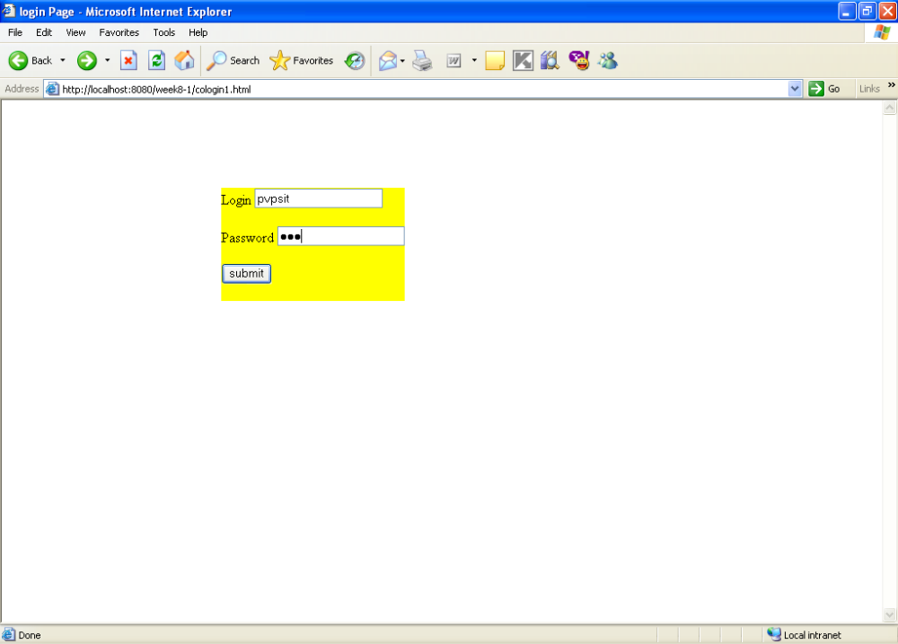

Cookie Added

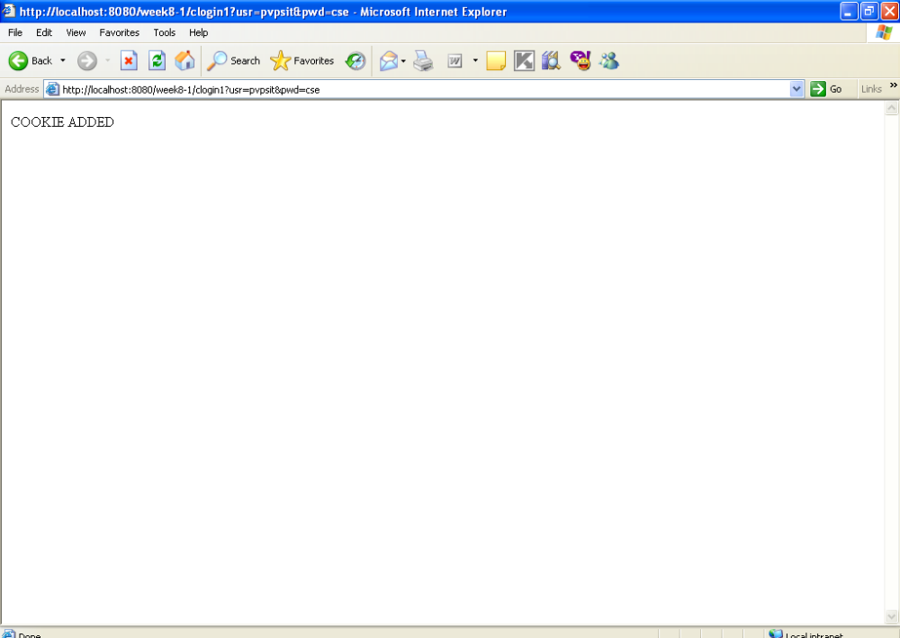

Display Cookie
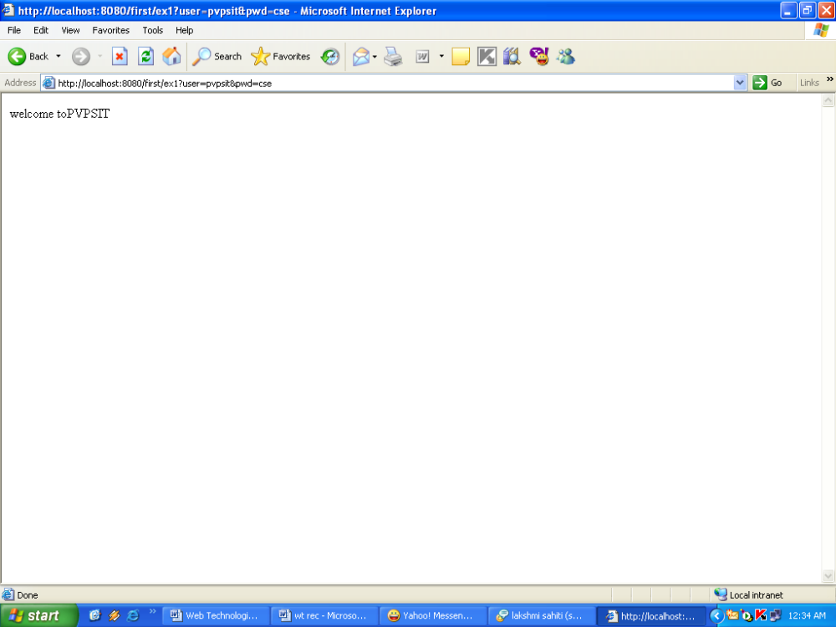

References:

- Web Technologies- A computer science perspective By Jeffery C. Jackson, Pearson
- Web Technologies-TCP/IP Architecture, and Java Programming By Achyut S. Godbole
- Web Technology-A Developer’s Perspective by N.P Gopalan,J.Akilandeswari,PHI Learning

FAQ

- What is Cookie? What are the types of cookies?
- How to initialize and create the cookie in JSP?
- How to remove the cookie?
- How to initialize and create cookie in PHP?

